**ESA Mentorship Program**

**Mentor Handbook**

**Table of Contents**

Disclaimer 2

Acknowledgement 2

Introduction 3

ESA Mentorship Program Structure and Duration 4

What is Mentoring? 6

Purpose of Mentorship 6

The Different Types of Mentors 7

Tips for Being a Great Mentor 8

Handling Challenges as a Mentor 9

Frequently Asked Questions 10

How do I become a mentor? 10

How does the initial meeting work? 10

What is the duration of the mentoring relationship? 10

How often should meetings occur? 10

Can I have more than one mentee? 10

What if I no longer wish to accept more mentees or decide to discontinue my role as a mentor in the mentorship program? 10

How do I handle challenges in the mentoring relationship? 10

What should I do if I need to end the mentorship relationship early? 10

Will negative feedback impact my standing in the ESA or the Mentorship Program? 11

Can I apply to be a mentor and also seek mentorship from others? 11

Who should I contact if I have further questions? 11

Conclusion 12

# Disclaimer

The information provided in this Mentor Handbook is intended to serve as a general guide for mentors participating in the Endocrine Society Australia's (ESA) Mentorship Program. While every effort has been made to ensure the accuracy and relevance of the content, the ESA does not guarantee that the information is comprehensive, complete, or free from errors.

The handbook is designed to support mentors in their roles and to facilitate productive mentoring relationships. However, the ESA cannot assume responsibility for the outcomes of individual mentoring relationships or for any decisions made based on the guidance provided herein. Mentors and mentees are encouraged to exercise their own judgment and seek additional advice as needed.

The ESA reserves the right to modify or update the handbook as necessary to reflect changes in program guidelines or best practices. By participating in the Mentorship Program, mentors agree to adhere to the principles and expectations outlined in this handbook, while understanding that the program’s success is dependent on mutual commitment and cooperation between mentors and mentees.

# Acknowledgement

The ESA Mentorship Program is an initiative of the 2024 ESA Early Career Committee (ECC). The 2024 ECC members are:

Lachlan Angus

Amy Dwyer

Elizabeth Wootton

Angela Sheu

James McNeil

Lauren Tyack

Ed Mignone

Chau Thien (Jillian) Tay

Mawson Wang

The mentorship program has been thoughtfully designed by:

Chau Thien (Jillian) Tay

Mawson Wang

Edward Mignone

This handbook is prepared by:

Chau Thien (Jillian) Tay

Last updated 2024

All illustrations used in this handbook are public domain images sourced from Freepik.

# Introduction

Welcome to the ESA Mentorship Program Mentor Handbook. This guide is designed to support you as a mentor, providing essential information to help you navigate your role and contribute effectively to the program. Our mentorship initiative aims to foster professional development by connecting experienced clinicians and researchers with emerging talent in the field of endocrinology.

The purpose of this handbook is to guide you through your role as a mentee, outlining your responsibilities, the structure of the mentorship process, and the resources available for a successful mentoring experience. By following these guidelines, you will be well-prepared to engage effectively with your mentor, ensuring a productive and rewarding relationship that supports your professional growth and development.

We appreciate your commitment to the program and look forward to your active participation. Your role is crucial in shaping the future of endocrinology, and this handbook will serve as a valuable resource throughout your mentoring journey.



# ESA Mentorship Program Structure and Duration

The ESA Mentorship Program is designed to facilitate meaningful connections between mentors and mentees within the field of endocrinology. Profiles of volunteers who have agreed to participate as mentors are listed on our website, providing mentees with the opportunity to select potential mentors based on their areas of expertise and interests.

The mentorship relationship is expected to be led by the mentee. This means that mentees are responsible for initiating contact with potential mentors, sending Expressions of Interest (EOIs), and organizing meetings. Mentors have the discretion to decide whether to accept an initial meeting with a mentee. It is important to note that an initial meeting does not automatically establish a mentorship relationship; both parties must agree that the match is appropriate and mutually beneficial.

Following a successful initial meeting, if both the mentor and mentee agree to proceed, the mentee is required to complete the ESA Mentorship Program Agreement Form. This form will formalize the mentorship relationship, including the agreed frequency of meetings. The mentee is responsible for scheduling and facilitating all subsequent meetings. The program is structured to last for 12 months, but either party may choose to terminate the relationship or extend it beyond the initial period as needed.

Mentors may choose to work with more than one mentee. However, it is crucial that mentors ensure they can dedicate adequate time and attention to each mentee to uphold the quality of the mentoring relationship. If you no longer wish to accept additional mentees or decide to discontinue your role as a mentor in the ESA program, please notify the ESA mentorship program coordinators as soon as possible. We will then either mark your profile as "unavailable" or remove it from the program, based on your preference.

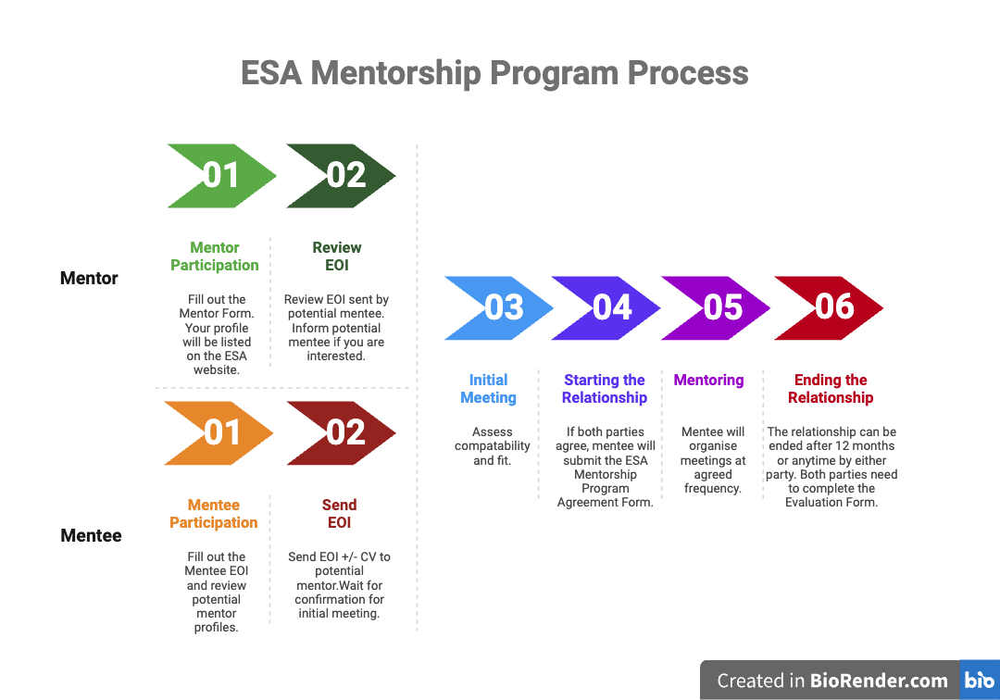

***Advice provided and discussions held between the mentor and mentee must be kept confidential and not disclosed to any third party, unless mutually agreed by the mentor and mentee. Any advice, comments, suggestions, opinions or information (in either individual or combined occurrence) imparted (verbally, in written or electronic correspondence, or by a combination of these) are given with the best intentions and according to the best knowledge of the mentor involved. Whilst every care is taken to deliver accurate and complete advice, comments, suggestions, opinions or information (in either individual or combined occurrence), no liability whatsoever attaches to the mentor nor to ESA in any way as a result of giving that advice.***

**Essential forms to be completed by mentor:**

1. Mentor Expression of Interest Form
2. End of Mentorship Program Evaluation Form (optional)*

* The evaluation form is optional, but completing it helps us assess the program's effectiveness, refine its structure, and secure ongoing support from the ESA.

# What is Mentoring?

## Purpose of Mentorship

**What is Mentoring?**

Mentoring is a professional relationship where a seasoned individual (the mentor) provides strategic guidance, constructive feedback, and support to a less experienced person (the mentee). This process involves the mentor leveraging their expertise to aid the mentee’s development in specific areas such as career progression or personal growth. Rather than dictating solutions, the mentor helps the mentee build their skills and confidence to make informed decisions and achieve their objectives effectively.

**What is Not Mentoring?**

Mentoring is not a one-sided relationship where the mentor merely provides answers or solutions. It is not a replacement for formal training or education, nor is it a platform for the mentor to assert dominance or control. Mentoring is not about providing unsolicited advice or making decisions for the mentee. It is not counselling, which focuses on addressing personal issues and emotional support. Instead, mentoring is a supportive and interactive process that respects the mentee’s autonomy and encourages their own problem-solving and decision-making abilities.

**Mentoring vs Coaching**

Mentoring and coaching, while both valuable for professional development, serve different purposes and involve distinct approaches.

In mentoring, the mentee drives the relationship, setting goals and bringing forward the challenges they wish to address. The mentor offers guidance and support based on their experience, helping the mentee navigate their personal and professional growth. Mentoring is often broader, focusing on long-term career development and personal development.

Coaching is more directive. In this relationship, the coach sets the agenda, concentrating on specific performance goals or skills. The coach helps the mentee achieve targeted objectives through structured interventions and feedback. While mentoring is typically more exploratory and developmental, coaching is goal-oriented, emphasizing measurable improvements and skill enhancement.



# The Different Types of Mentors

In mentoring relationships, different types of mentors can fulfill various roles depending on their approach and the needs of the mentee. Here are several types of mentors:

|  |  |
| --- | --- |
|  | **Advisor:** Provides strategic advice and guidance based on their experience and expertise in a specific area. They help mentees navigate complex decisions and plan their career paths. |
|  | **Coach:** Focuses on developing the mentee’s skills and competencies through feedback and practice. They often help mentees improve performance and achieve specific goals. |
|  | **Protector:** Supports and defends the mentee within the organization or field. They offer advocacy and ensure that the mentee’s achievements and contributions are recognized and valued. |
|  | **Connection Broker:** Uses their network to connect the mentee with valuable contacts and opportunities. They help mentees build relationships and expand their professional network. |
|  | **Challenger:** Pushes the mentee to step out of their comfort zone and challenge their assumptions. They encourage growth by presenting new perspectives and fostering critical thinking. |
|  | **Affirmer:** Provides emotional support and validation. They help boost the mentee’s confidence and morale, reinforcing their strengths and achievements. |
|  | **Sponsor:** Actively advocates for the mentee’s advancement and opportunities. They use their influence to promote the mentee’s career progression and open doors for new opportunities. |

Each type of mentor plays a distinct role in supporting the mentee’s development and can be valuable depending on the mentee’s needs and goals.

# Tips for Being a Great Mentor

1. **Be an Active Listener:** Engage attentively with your mentee’s concerns and aspirations. Listen more than you speak to fully understand their needs and perspectives, which helps in providing relevant and meaningful advice.
2. **Provide Constructive Feedback:** Offer feedback that is both supportive and actionable. Focus on the mentee’s strengths while addressing areas for improvement, ensuring your feedback is specific, objective, and aimed at fostering their growth.
3. **Set Clear Expectations:** Establish clear goals and expectations at the outset of the mentoring relationship. Define the scope of your mentorship, agree on meeting frequencies, and outline what both parties hope to achieve.
4. **Encourage Self-Reliance:** While offering guidance and support, encourage your mentee to take initiative and make their own decisions. This promotes their independence and helps them build confidence in their abilities.
5. **Share Knowledge and Resources:** Provide your mentee with valuable insights, resources, and connections that can aid their development. Sharing your expertise and experiences can significantly enhance their learning and career progression.
6. **Celebrate Achievements:** Recognize and celebrate your mentee’s progress and accomplishments. Acknowledging their successes reinforces their motivation and commitment to their development.
7. **Respect Confidentiality:** Uphold confidentiality in all discussions with your mentee. Create a safe space where they feel comfortable sharing their challenges and goals without fear of judgment or breach of privacy.
8. **Address Issues Promptly:** If you encounter difficulties or incompatibilities in the mentoring relationship, address them openly and constructively. If needed, help the mentee find alternative support or resources.



# Handling Challenges as a Mentor

Mentoring, while rewarding, can also present challenges. Addressing these challenges effectively is crucial to maintaining a productive and supportive mentoring relationship. Here are some strategies for handling common challenges:

1. **Navigating Miscommunication:** Miscommunication can occur in any mentoring relationship. To address this, ensure that both you and your mentee are clear about expectations and goals. Regularly check in to confirm understanding and provide opportunities for feedback. If misunderstandings arise, address them promptly and openly to avoid escalation.
2. **Managing Conflicts:** Conflicts may arise due to differing perspectives or expectations. Approach conflicts with a problem-solving mindset. Focus on the issue at hand rather than personal differences, and work collaboratively to find a resolution. Open dialogue and active listening are key to resolving conflicts and restoring harmony in the mentoring relationship.
3. **Addressing Lack of Progress:** If you notice that your mentee is not making the expected progress, engage in a constructive discussion to identify the underlying causes. Assess whether the goals are realistic or if adjustments are needed. Offer additional support, resources, or guidance as necessary to help your mentee overcome obstacles.
4. **Dealing with Disengagement:** Sometimes, a mentee may become disengaged or less motivated. If this occurs, explore the reasons behind their disengagement. Have a candid conversation to understand their current challenges or changes in their goals. Reaffirm your commitment to their development and work together to re-establish engagement and motivation.
5. **Managing Time Constraints:** Balancing mentoring with other responsibilities can be challenging. Ensure you and your mentee agree on a realistic schedule for meetings and communication. If time constraints become a significant issue, discuss possible adjustments to the frequency or format of meetings to better accommodate both parties' schedules.
6. **Handling Ethical Dilemmas:** Occasionally, ethical dilemmas may arise, such as confidentiality concerns or conflicts of interest. Maintain professional integrity by adhering to ethical standards and guidelines. If you face an ethical dilemma, consult with trusted colleagues or seek advice from relevant professional bodies to navigate the situation appropriately.
7. **Ending the Relationship:** If the mentoring relationship needs to be concluded, whether due to incompatibility or other reasons, do so with sensitivity and professionalism. Communicate openly about the decision, provide constructive feedback, and, if possible, help your mentee find alternative support or resources.

By proactively addressing these challenges, you can ensure a positive and impactful mentoring experience. Effective handling of issues strengthens the mentoring relationship and contributes to the overall success of both you and your mentee.

# Frequently Asked Questions

How do I become a mentor?  
To become a mentor, you need to complete the relevant Mentor Agreement Form available on our website. Mentors can express their interest in participating, while mentees can browse mentor profiles and submit their expressions of interest (EOI) to potential mentors.

How does the initial meeting work?  
After reviewing a potential mentee’s expressions of interest (EOI), you can decide if you would like to have an initial meeting. The initial meeting is an opportunity for both the mentor and mentee to assess compatibility and discuss expectations. This meeting is crucial to determine if both parties agree to proceed with the mentoring relationship.

What is the duration of the mentoring relationship?  
The mentoring relationship is initially set for a 12-month period. However, both parties can choose to terminate the relationship at any time or extend it if mutually agreed upon.

How often should meetings occur?  
Mentors and mentees are responsible for agreeing on the frequency and timing of their meetings. The mentee typically takes the lead in organizing and scheduling these meetings.

## Can I have more than one mentee?

Yes, mentors can have more than one mentee. However, it is important that mentors ensure they can provide adequate time and attention to each mentee to maintain the quality of the mentoring relationship. If a mentor chooses to take on multiple mentees, they should manage their commitments effectively to support each mentee's development and goals.

## What if I no longer wish to accept more mentees or decide to discontinue my role as a mentor in the mentorship program?

If you no longer wish to accept additional mentees or wish to discontinue your role as a mentor in the ESA program, please notify the ESA mentorship program coordinators as soon as possible. We will either mark your profile as "unavailable" or remove it from the program, depending on your preference.

How do I handle challenges in the mentoring relationship?  
Challenges should be addressed openly and constructively. If issues arise, both parties should communicate their concerns and work together to find solutions. Remember, mentoring is a collaborative process.

If either the mentor or mentee feels that the relationship is not working, they should communicate openly and consider ending the relationship.

## What should I do if I need to end the mentorship relationship early?

If you need to end the relationship before the 12-month period, inform your mentor/mentee as soon as possible. Complete the End of Mentorship Program Evaluation Form to provide feedback on the experience.

## Will negative feedback impact my standing in the ESA or the Mentorship Program?

Negative feedback does not affect your standing in the ESA or the Mentorship Program. The purpose of feedback is to identify areas for improvement and to enhance the Mentorship Program.

## Can I apply to be a mentor and also seek mentorship from others?

Yes, you can apply to be a mentor while also seeking mentorship from others. This dual role can enhance your professional development and contribute your effectiveness as a mentor. Just be sure to manage your time and commitments effectively to ensure both roles are fulfilling.

Who should I contact if I have further questions?  
For additional questions or support, please contact the ESA mentorship program coordinators via: esamentorship@endocrinesociety.org.au.

# Conclusion

As we conclude this handbook, we emphasize that effective mentoring is a dynamic and reciprocal process that requires dedication, empathy, and clear communication. By understanding your role as a mentor and embracing the responsibilities and skills outlined in this guide, you are well-positioned to foster meaningful and impactful relationships with your mentees.

Remember, mentoring is not just about guiding others, but also about continuous learning and personal growth. The relationships you build can significantly influence both your own professional development and the success of those you mentor.

Thank you for your commitment to the ESA Mentorship Program. Your contributions are invaluable in shaping the future of endocrinology and advancing excellence within our community. We encourage you to approach each mentoring relationship with openness and enthusiasm, and to continuously seek ways to enhance your mentoring practice.

